Sea-Level Rise Effects on Coastal Shallow Groundwater Dynamics in the Built Environment
Amandine L. Bosserelle¹
¹ Waterways Centre, School of Earth and Environment, University of Canterbury, Christchurch

- Overall aim
From small coastal settlements to large cities, communities are exposed to both the direct and indirect consequences of climate-change induced sea-level rise (SLR). Above the ground surface, short- and long-term coastal effects of SLR are visible and cause damage from flooding, erosion, and loss of habitats and ecosystems. Below the ground surface, the effects are less visible but nonetheless extensive (e.g., water table rise, salinisation). Groundwater is present at shallow depth in the coastal zone and the effects of SLR on shallow groundwater threaten water security, agricultural production and infrastructure. Groundwater flooding, a hydrological hazard results from the process of water table rise, where the groundwater surface intersects or goes above the land surface due to changing conditions (e.g., SLR or more extreme and frequent rainfall events due to climate change). The coastal zone is a complex dynamic space between saltwater and freshwater environments above and below the ground surface, and coastal groundwater hazards are intensified due to SLR. However, current monitoring of coastal shallow groundwater levels and water quality (e.g., salinity) does not occur sufficiently to mitigate and adapt to the groundwater hazard.
This research consists of five studies and provides insights into the dynamics of coastal shallow groundwater, urban monitoring networks, simulations of water table rise and the issues posed by shallow groundwater changes driven by SLR and effects on flooding.
- Study 1
The first study reviewed processes of coastal groundwater rise and simulation tools used to evaluate possible impacts of SLR (Bosserelle et al. 2022). The two main methods to assess coastal groundwater rise and its contribution to flooding - spatial interpolation and numerical tools - were discussed, and the benefits and limitations of each were analysed. The review highlighted the need for methodology comparisons between spatial interpolation and numerical tools to guide future work. The simulation tools that are used to evaluate changes in urban hydrogeology due to SLR do not specifically estimate groundwater flooding. Current monitoring practices do not capture evidence for groundwater rise with SLR. Therefore, the assessment methods need to rely on improved coastal groundwater monitoring networks focused on water quality, saltwater intrusion, and continuous groundwater levels records near the coastline, tidally influenced surface water bodies, and critical infrastructure.
- Study 2
The second study focused on an urban shallow groundwater monitoring network and assessed its development, current physical condition and usefulness for SLR research (Bosserelle and Hughes, under review). Following the 2010-2011 Canterbury Earthquake Sequence, in Ōtautahi Christchurch, Aotearoa New Zealand, shallow groundwater data acquisition and establishment of a geotechnical database provided unprecedented information on subsurface conditions. The monitoring infrastructure provided high spatio-temporal resolution records of shallow groundwater levels, which opened the field of New Zealand-based urban groundwater studies. Field surveys and digital information review showed overall good condition and robustness of the monitoring network, despite some maintenance issues. The dataset held by the city and regional councils should be more widely used to benefit the community, urban water management, researchers and practitioners facing decisions to adapt and protect coastal areas from the impacts of climate change and SLR.
- Study 3
The third study determined characteristics of shallow groundwater, including spatial and temporal trends in depths to groundwater and their relationship to natural and anthropogenic stressors (Bosserelle et al. 2024). The study used depth to groundwater measurements from the uniquely extensive and densely spaced monitoring network in Ōtautahi Christchurch, Aotearoa New Zealand. Data-driven analysis approaches were applied, including spatial interpolation, autocorrelation, clustering, cross-correlation, and trend analysis. This comprehensive approach revealed discernible clusters and trends within the dataset, providing valuable insights into the spatial and temporal variability of shallow groundwater in urban coastal settings. Responses to stresses such as rainfall events and stream flow were successfully classified using clustering analysis while anthropogenic influences were more challenging. The primary feature in hydrograph classification proved to be the proximity to tidal rivers and their correlation with tidal signals. This study highlighted the importance of monitoring coastal groundwater and the need for a better understanding of its effects on urban infrastructure and the built environment.
- Study 4
The fourth study focused on simulating the effects of SLR on water table rise (Bosserelle and Morgan, in preparation). These processes may lead to groundwater flooding and infrastructure challenges. A numerical model was used to assess the transient water table movement in response to SLR. Various SLR scenarios and rates were used to simulate the magnitudes and rates of water table rise, considering a range of aquifer parameters for both fixed-head and fixed-flux inland boundary conditions. The magnitudes and rates of water table rise were always less than but proportional to SLR and decreased with distance from the coastline. The magnitude and rate of water table rise in response to SLR were the largest for fixed-flux inland boundary conditions, but it takes a long time to conditions to equilibrate. Fixed-flux conditions were found to pose a greater hazard as the maximum impact may not be experienced for decades, posing challenges to planners and managers of coastal groundwater systems. Adding a drain reduced the magnitude and rate of water table rise, more on the inland side than on the coastal side.
- Study 5
The final study examined the key impacts of SLR on coastal shallow groundwater, and subsequent challenges faced by infrastructure asset managers (Bosserelle and Hughes, under review). The study showed that current and future issues such as saltwater intrusion, flooding, and earthquake liquefaction hazard due to groundwater are exacerbated by climate change-driven SLR. A key issue is determining who will take responsibility for shallow groundwater management in areas with multiple and overlapping local government jurisdictions. Another key finding is that current techniques to manage groundwater in infrastructure construction/operation and land management will be applied in future, and challenges to coastal infrastructure adaptation will be posed by political and economic considerations rather than technical understanding.
- References
Bosserelle, A. L., Morgan, L. K., & Hughes, M. W. (2022). Groundwater rise and associated flooding in coastal settlements due to sea‐level rise: a review of processes and methods. Earth's Future, 10(7), e2021EF002580. https://doi.org/10.1029/2021EF002580
Bosserelle, A. L., Morgan, L. K., Dempsey, D. E., & Setiawan, I. (2024). Shallow groundwater characterisation and hydrograph classification in the coastal city of Ōtautahi/Christchurch, New Zealand. Hydrogeology Journal, 32(2), 577-600. https://doi.org/10.1007/s10040-023-02745-z
Bosserelle, A. L., Hughes, M. W. (under review) Groundwater monitoring infrastructure: Evaluation of the shallow urban and coastal network in Ōtautahi/Christchurch. Submitted for publication in December 2023 in the Journal of Hydrology: Regional Studies.
Bosserelle, A. L., Hughes, M. W. (under review) Practitioner perspectives on sea-level rise impacts on shallow groundwater: Implications for infrastructure asset management and climate adaptation. Submitted for publication in March 2024 in the journal Urban Climate.
Bosserelle, A. L., Morgan, L. K. (in preparation) Transience of coastal water table rise in response to sea-level rise.

What’s happened to our lake? characterizing the development of a high mountain Kapuche glacial lake in Nepal
Gurung, R.,¹ Doscher, C.,¹ MacDonell, S.^{1,2}
¹ Lincoln University, New Zealand
² University of Canterbury, New Zealand

Aims
The Himalayas in Nepal are no exception to the impacts of global climate warming. Increased melting of glaciers has facilitated the development of new glacial lakes and the subsequent expansion of the existing ones. One such lake that was first noticed in 2001 in Landsat imagery is Kapuche Lake situated at the foothills of Annapurna and Lamjung Himal, Nepal. Though it falls below the elevation criteria for a glacial lake in the Nepali Himalayas as defined by the International Center for Integrated Mountain Development (ICIMOD), within 25 years (2000 – 2024) it has changed from a meltwater stream to a lake covering an approximate area of 0.1 km², and downstream communities have greatly benefitted from the resulting rise in tourism development, and from this new water source for hydropower generation and irrigation. Amidst intensifying climate crises, how these rapid changes in the lake will shape Glacier Lake Outburst Flood (GLOF) danger and way of living for communities downstream remains a subject of debate. This research aims to understand what is driving the expansion of the lake and how is it responding to various environmental and geomorphological factors as a first step to better preparing for potential hazards.
Method
Remote sensing data and technologies have emerged as valuable resources for monitoring changes in glacial environments which otherwise are often presented with formidable challenges due to harsh weather conditions, remote locations, and inaccessible terrains (Wangchuk et al., 2022). Vast increases in the availability of free and open-access data have further advanced the use of these techniques for remote observations of the mountain cryosphere. Similarly, for this study, high-resolution satellite images acquired by Advanced Spaceborne Thermal Emission and Reflection Radiometer (ASTER), Landsat, Sentinel-2 multi-spectral instrument (S-2 MSI), and Sentinel-1 Synthetic Aperture Radar (S-1 SAR) were used to study the characteristics and dynamic change of Kapuche Lake and its surroundings including glacial melt, lake area, open water area, lake ice area, slope stability, avalanche dates. Most of the data analysis was performed using the Google Earth Engine (GEE) platform. The images were pre-processed and necessary band calculations (Normalised Difference Water Index, Normalised Difference Vegetation Index, and Normalised Difference Snow Index) were done to enhance the lake and glacier characteristics from 2000 to 2024.
Results
Preliminary results show that the lake area changed from 0.009 km² to 0.9 km² from 2000 to 2024 with a maximum area of 0.11 km² in 2012 (Figure 1). Frequent avalanches are suggested to be the main factor for its expansion.
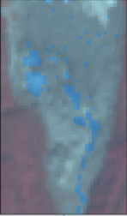
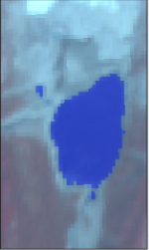
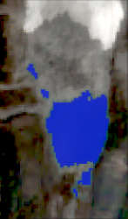
2024
2012
2000

Figure 1: Changes in Kapuche Lake area over the years.

References
Wangchuk, S., Bolch, T., & Robson, B. A. 2022. Monitoring glacial lake outburst flood susceptibility using Sentinel-1 SAR data, Google Earth Engine, and persistent scatterer interferometry. Remote Sensing of Environment, 271(112910).

MULTI-DOMAIN ECOSYSTEM TYPOLOGIES - TOWARDS A UNIFIED APPROACH IN AOTEAROA NEW ZEALAND

Karen Houghton,¹ Rowan Sprague,^{2,} Susan Wiser,² James McCarthy,² Olivia Burge,² Louise Weaver,³ Annette Bolton,³ Susie Wood,⁴ Carolyn Lundquist,⁵ Doug Booker, ⁵ Paul Franklin ⁵
¹ GNS Science
² Manaaki Whenua - Landcare Research
³ ESR
⁴ Cawthron Institute
⁵ NIWA
Aims
Ecosystem typologies are frameworks to classify ecosystems into groups and can be used to describe the degree of similarity between ecosystem types (Keith et al. 2022). They form fundamental infrastructure for biodiversity protection, monitoring, management and research. They can be used to manage land use and development, guide natural area protection, infrom conservation planning, monitor environments, and support ecological research and understanding across domains. The International Union for Conservation of Nature Global Ecosystem Typology (IUCN GET) has developed a framework for environmental reporting at the global scale (Keith et al. 2022).

While some environments (e.g. rivers, terrestrial habitats) in Aotearoa New Zealand have existing typologies, there is not a unifying typology that brings these together in a conceptual framework. The Ministry for the Environment (MfE) commissioned Manaaki Whenua – Landcare Research (MWLR), in collaboration with NIWA, Cawthron, ESR, and GNS, to investigate a unifying ecosystem typology for Aotearoa New Zealand.

Method

This project covers six domains (environments): Rivers, Lakes, Groundwater, Marine and Estuarine, Wetlands and Terrestrial. As part of this project, we investigated international unifying typologies and undertook an in-depth analysis of the IUCN GET and its potential to fit with local typologies being applied in Aotearoa New Zealand. We also cross-checked the use and implementation of the IUCN GET by analysing the approaches taken in other countries (Sprague and Wiser, 2024).

Existing typologies for the six domains were assessed against a set of principles developed by representatives from MfE, Department of Conservation and Regional Councils, as well as their potential to map to the IUCN GET. The challenges anticipated with developing and implementing a unifying framework in Aotearoa New Zealand, including options for how to mitigate and manage these, were identified.

Results

For each domain, we assessed existing typologies against the predefined principles (Burge 2024, Franklin and Booker 2024, Houghton et al 2024, Lunquist et al 2024, McCarthy and Wiser 2024, and Wood and Schallenberg, 2024). We also presented a roadmap that outlines the steps required to achieve a revised ecosystem typology for each domain which is consistent with the principles and requirements, and which nests under the IUCN GET (Figure 1). We investigated methods for cross-walking from local typologies to IUCN GET in order to help fulfil international reporting requirements. The benefits of co-ordinated mapping and integrated governance for operation of a unified ecosystem typology were identified.

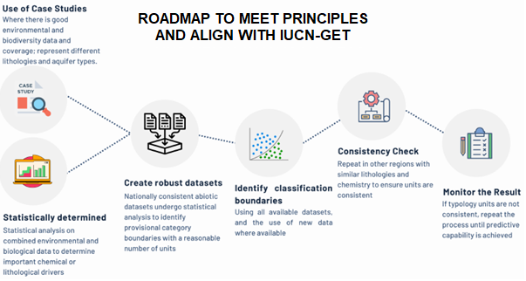
Figure 1: Example graphical roadmap to create a unifying typology for groundwater.

References
Burge, O.R. 2024. Roadmap to update existing typology for wetlands to align with the Principles and Typology Requirements and the IUCN GET. In preparation.
Franklin, P. and Booker, D. 2024. Roadmap to update the existing ecosystem typology for rivers. Hamilton (NZ): NIWA. 35 p. (NIWA Client Report 2024229CH).
Houghton KM, Bolton A, Weaver L. 2024. Roadmap to update existing typology for groundwater to align with the Principles and Typology Requirements and IUCN-GET. Lower Hutt (NZ): GNS Science. 16 p. (GNS Science report; 2024/35).
Keith, D.A., Ferrer-Paris, J.R., Nicholson, E., Kingsford, R.T. (Eds.), 2020. IUCN Global Ecosystem Typology 2.0: descriptive profiles for biomes and ecosystem functional groups. IUCN, International Union for Conservation of Nature, Gland, Switzerland.
Lundquist, C., Brough, T., Hume, T., Rowden, A. and Melson, W. 2024. Roadmap to update the existing ecosystem typology for the marine and estuarine domain. Hamilton (NZ): NIWA. 35 p. (NIWA Client Report 2024230HN).
McCarthy, J.K. and Wiser, S.K. 2024. Roadmap to update the existing typology for terrestrial ecosystems. In preparation.
Sprague, R.I. and Wiser, S.K. 2024. Investigating a unifying ecosystem typology for all of New Zealand. In preparation.
Wood, S.A. and Schallenberg, L. 2024. Roadmap to update existing lake typologies to align with the MfE Principles and Requirements and the IUCN GET. In preparation.

Climate variability and climate change uncertainties in predicting suspended sediment yields in mountain catchments
Sarah Mager,¹ Sophie Horton,² Daniel Kingston¹
¹ University of Otago
² University of Canterbury

Introduction
Projections of the effects of climate change on New Zealand mountain catchments indicate a significant reduction in snow days and ice cover (Neverman et al., 2023), as well as significant changes in precipitation and runoff generation. Changes in snow and spring melt processes and the distribution of rainfall will impact the amount of suspended sediment transported through mountain catchments, and potentially its seasonal distribution. Projections are, however, hampered by a paucity of long-term monitoring of rainfall or runoff in New Zealand’s mountain catchments, and few measurements of suspended sediment. To investigate the effect that climate variabiity has on suspended sediment concentrations we used the Haast River as a case study, examining in situ turbidity response to different weather events (‘climate variability’) and how these may relate to seasonal effects and short-term climate oscillations (ENSO, SAM, MJO). Additionally we also consider the potential changes in runoff by undertaking climate change scenario modelling by applying the HBV-light model to model runoff for 2081–2100 under for RCP4.5 and 8.5 using six GCMs (‘climate change’). The aim of the study is to understand the scale and magnitude of uncertainty in suspended sediment observations using current observations and how these compare to uncertainties of future predictions in suspended sediment concentrations.

Study Area and Methods
Located in cool temperate rainforest of western New Zealand, the Haast/Awarua River drains a steep (mean slope of 29º) forested mountain catchment of 1356 km² (Fig. 1). Underlain with a high grade metamorphic schist and semi-schist lithology, the catchment has a high suspended sediment yield of 4,356 t/km²/yr (Hicks et al., 2011) which is a product of the steep rainfall gradient with 2500 mm/yr at the coast (Haast township), increasing to 5500 mm/yr (Roaring Billy) where flow is measured, and an area weighted rainfall of 6500 mm/yr.

Daily rainfall is recorded at Haast Township (1943– ), and rainfall (1989– ) and stream flow (1970– ) are recorded at Roaring Billy by the West Coast Regional Council and NIWA. A campaign of time-interval suspended sediment sampling over 4 storms events (Jan 2019, Feb 2019, Jan 2020, and Feb 2020) was undertaken to calibrate SS-turbidity rating curve. Bulk sediment sampling was undertaken at Pleasant Flat, Upper Haast, and Landsborough tributaries concurrent with 2020 storms. Continuous DTS-12 in situ turbidity monitoring (2014– ) and monthly sampling of water quality parameters at Roaring Billy (1989– ) is maintained as a part of NIWA’s hydrometric network. Event-analysis of turbidity was used to characterize the timing and phasing of sediment response into either: anticlockwise, clockwise, or concurrent hysteretic patterns and classified using HARP parameterization (Roberts et al. 2023). Forthcoming analysis of event responses will be further classified according to climate variability to ascertain whether different types of hysteresis response occurred in response to different climate oscillations.

A hydrological model was developed to simulate river flow at Roaring Billy using HBV-Light for the baseline period (1970–2000) and scenario climate change modelling (2081-2100) for the RCP8.5 scenario (RCP4.5 forthcoming). Six GCM model outputs were downscaled for the region and used in the analysis: BCC, CESM, GFDL, GISS, HadGEM, NorESM. Rainfall records are, however, patchy and affect hydrological model performance as model calibration showed a good fit to monthly runoff totals (.NSE = 0.65) but poorer performance at the daily time step (NSE = 0.42). Forthcoming work will re-run the model using ERA-5 Total Precipitation, which has been shown to significantly improve rainfall estimates.

Results
The Haast/Awarua typically has a sediment peak following peak runoff (anticlockwise hysteresis). Under some conditions of temporary sediment exhaustion the sediment peak may arrive before peak runoff (clockwise hysteresis) or concurrent to peak runoff (Table 1). Although infrequent clockwise hysteresis or concurrent peaks in sediment and discharge occur from late autumn through to early spring – suggesting reduced mobilisation with snow cover.

Table 1 Example of Haast/Awarua River hysteretic response of turbidity as measured in situ for 2019–2020 for flow events above 65 mm/d (800 cumecs).

 | Clockwise | Anticlockwise | Concurrent
Number of events | 3 | 26 | 8
Lag time (hours) | 1–2 | 3 | 0
Season of occurrence | Autumn, Winter, Spring | Year Round | Autumn, Spring

High uncertainty in runoff exists between different GCM climate scenarios, but generally show an increase in runoff for most months (Fig. 1), increasing > 200 mm per month over winter. RCP 8.5 shows significant declines in snow cover for the Haast Awarua catchment and as a result shows a notable increase in runoff during the austral winter.

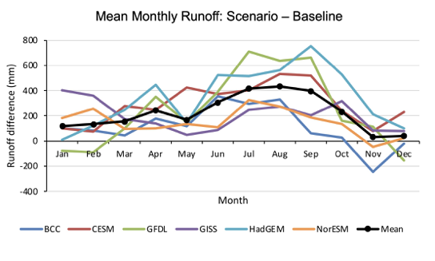
Figure 1. Mean monthly runoff difference between GCM scenario and baseline. All models predict an increase in austral winter runoff, with the mean of all models suggesting increased runoff for all months by 2090 under RCP 8.5.

Implications
The reduction in ice and snow may further reduce the production of suspended sediment in the headwaters, potentially resulting in temporary suspended sediment exhaustion during late summer and autumn – an effect that has already been detected by in situ measurements of nephelometric turbidity. Climate variability likely has the greatest uncertainty on sediment yields in the near future, however, the overall impact of climate change is likely to alter sources of sediment and the phasing of its release into the river network, and as such may affect the suitability of existing sediment rating curves for estimating physical weathering fluxes in mountain catchments.
Reference List
Neverman, A. J., Donovan, M., Smith, H. G., Ausseil, A. G., & Zammit, C. 2023. Climate change impacts on erosion and suspended sediment loads in New Zealand. Geomorphology, 427, 108607.
Hicks, D. M., Shankar, U., McKerchar, A. I., Basher, L., Lynn, I., Page, M., & Jessen, M. 2011. Suspended sediment yields from New Zealand rivers. Journal of Hydrology (New Zealand), 50(1), 81-142.

NUTRIENT HYSTERESIS AND CHEMOGRAPHIC RESPONSE DURING ATMOSPHERIC RIVER FLOOD EVENTS
Sophie Horton,¹ Sarah Mager,² Nithin Krishna²
¹ University of Canterbury
² University of Otago

Introduction
Atmospheric rivers are narrow bands of high vapour transport that can produce intense rainfall and are a weather phenomenon associated with potential flooding. Such events can lead to localised mobilisation of nutrients and have been associated with coastal pollution events in California (Aguilera et al., 2019). When atmospheric rivers cause high inland rainfall associated with extremes events, their impact on mobilizing water contaminants is also in question, and little work to date has considered what impact this may have on water quality, especially in the overall export of nutrients from catchments (Husic et al., 2019). For example, nitrate pathways can include dilute quick flow, slow flow from subsurface stores, and concentrated quick flow – but which of these will dominate in an intensive atmospheric river event, and are these responses bespoke to each catchment, or more broadly consistent across catchments? The timing and relative nitrate contribution of these pathways are usually expected to result in a peak nitrate concentration that is delayed (“lagged”) relative to the hydrograph peak but recent work exploring the behavior of nitrate mobilization in Canterbury groundwater (Legg et al., submitted) has shown these are much more complex than a simple lag-response. Thus, the prevailing conceptual framework for understanding mobilization of solutes and the mixing of different flow pathways may be contingent on understanding the magnitude and intensity of rain events and hydrological coupling to subsurface stores. The importance of understanding these intensity effects becomes more important as climate change alters hydrological flow regimes. Therefore the aim of this study to is analyze the pattern of nutrient mobilization and flushing of solutes during flow events. By using rivers that have been sampled hourly across flow events we are interested in understanding whether there is commonality in nutrient hysteresis, or whether catchment characteristics continue to exert a stronger control on nutrient flushing and mobilization. Secondly, we are interested in considering what impact atmospheric rivers may have on nutrient export in the NZ context.

Study Area and Methods
Storm flow events have been sampled at an hourly resolution by collecting 500 mL samples using automatic water samplers with hose intakes secured in the main river channel in four catchments: Haast Awarua (Feb-19, Jan-20, Feb-20), Birch Hill Stream (Apr-15, May-19), Ahuriri (Sep-18, Mar-19), Oreti River (Nov-18) and Silver Stream (May-2010). The Haast River in south Westland is a large, forested mountain catchment (1300 km²), and Birch Hill Stream in mid-Canterbury is a small alpine headwater catchment (11 km²). The Ahuriri River is a large catchment in South Canterbury retained in tall tussock (550 km²), and the Oreti River is a mixed-use catchment with mountain headwaters but lowland agriculture (3500 km²). The Silver Stream is a small east coast catchment in Otago with forested headwaters and agricultural lowlands (45 km²).

Samples were analysed for their major (Na, Ca, Mg, K, Cl, SO₄, HCO₃), minor (NO₃, Si, PO₄), trace (Al, B, Ba, Fe, Me, Sr, Zn), and isotopic (δ¹⁸O) composition from hourly grab samples. Hysteretic analysis was undertaken using HARP parameterization, and bivariate plots of solute concentration with discharge (chemographs) were also plotted. Rainfall and flow data were collected from in-catchment gauging stations maintained by the local regional authority, NIWA, and the University of Otago. Multi-year water quality data was from monthly or quarterly environmental sampling undertaken by regional authorities was used to determine general trends in nutrients relative to discharge, and determining whether nutrient (N, P) concentrations were affected by antecedent flow events. The origins of the airmasses were reconstructed using ERA5 back trajectories and measures of atmospheric vapour transport (IVT) and the definition of atmospheric rivers were extracted from ERA5 using the TEMPEST algorithm.

Results
Preliminary analysis of event flows showed no consistent pattern in nitrate mobilisation between catchments with some catchments simply exhibiting simple dilution responses with high flow (e.g., Ahuriri, and Haast) (Fig. 1). Other responses showed an increase in nitrate on the receding limb suggesting greater hydrological connectivity of vadose stores of nitrate (e.g. Silver Stream and Birch Hill), or depletion on the receding limb (e.g. Birch Hill with a significant AR event) (Fig. 1). Other catchments, like the Oreti showed no hysteretic behaviour at all, rather nitrate increased and decreased concurrent with stream flow. Forthcoming work will explore each of these responses further by examining multi-year water quality records to assess whether the presence of an AR between sampling rounds increases, decreases, or has no effect on subsequent nutrient concentrations.

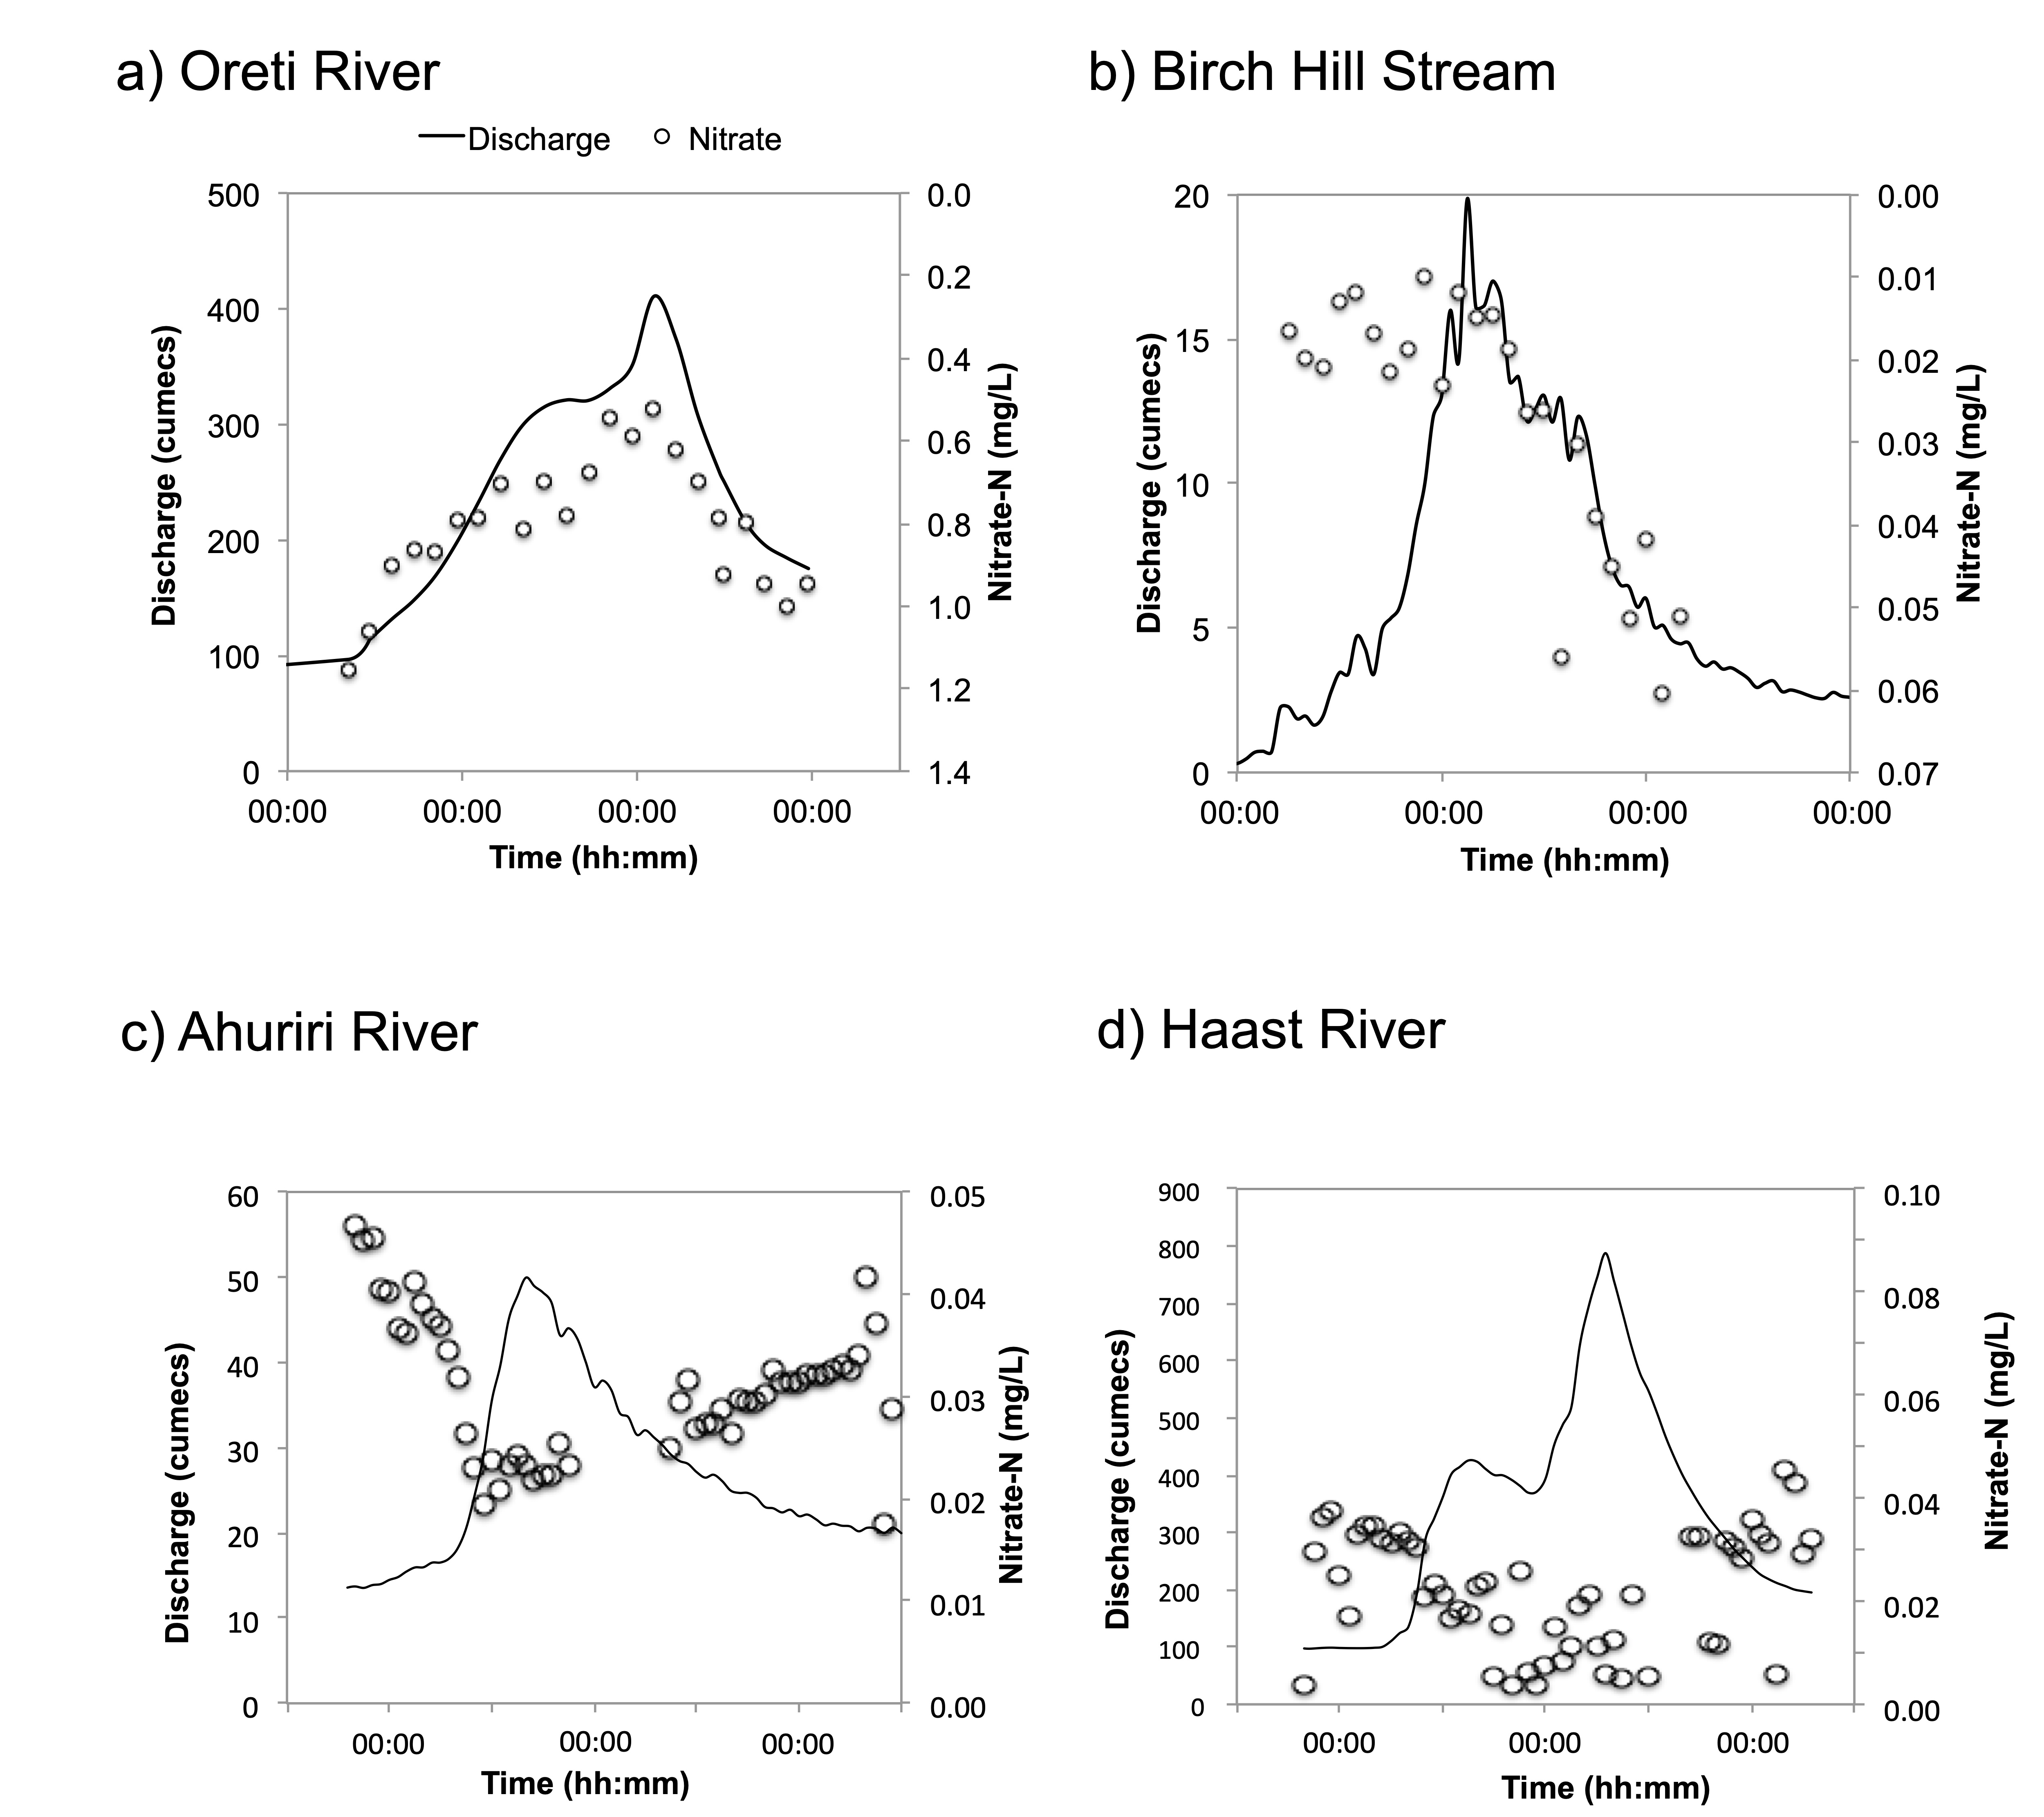

Figure 1. Event flow responses in nitrate for the a) Oreti River, b) Birch Hill Stream, c) Ahuriri River and d) Haast River.

Reference List

Aguilera, R., Gershunov, A., Benmarhnia, T. 2019. Atmospheric rivers impact California’s coastal water quality via extreme precipitation. Science of the Total Environment. 671, 488–494.
Husic, A., Fox, J., Adams, E., Backus, J., Pollock, E., Ford, W., and Agouridis, C. 2019. Inland impacts of atmospheric river and tropical cyclone extremes on nitrate transport and stable isotope measurements. Environmental Earth Science. 78:36. Doi:10.1007/s12665-018-8018-x.
Legg, J., Mager, S., and Horton, S. (submitted). Nitrate nitrogen response domains following a large-scale rainfall event on the Hekeao Hinds Plains of Mid Canterbury, New Zealand. Journal of Hydrology.
Roberts, M.E., Kim, D., Lu, J. and Hamilton, D.P., 2023. HARP: A suite of parameters to describe the hysteresis of streamflow and water quality constituents. Journal of Hydrology, 626, p.130262.

CHASinG Storms: tracking event flow in an alpine catchment
McMecking, J.,¹ MacDonell, S.,¹ Horton, T.,² Dudley, B.D.³
¹ Waterways Centre for Freshwater Management, University of Canterbury and Lincoln University
² School of Earth and Environment, University of Canterbury
³ National Institute of Water and Atmospheric Research

Introduction
Mountain catchments can be significant sources of freshwater, and the timing of discharge from mountain catchments has implications for ecological systems, as well as agriculture and industry. However, our understanding of the hydrological processes that occur during, and immediately after, precipitation and snowmelt events is limited (Penna et al., 2016). This is in large part because alpine environments experience harsh meteorological conditions that make data collection challenging (Beria et al., 2018). To address this challenge, data collection in cold regions needs to take a multi-method approach and should incorporate data collected in situ (by field workers and autonomously), and remotely. Autonomous sampling enables data to be collected in storm or during other adverse conditions, as data or samples can be subsequently collected when the weather conditions are more suitable.
Aims
The overall aim of this study is to understand the connection between storm events and hydrological response in a small mountain catchment. More generally, we seek to understand how hydrological processes controlling streamflow change during and after different types of precipitation events.
Method
Using Camp Stream as a case study, this study examines temporal patterns of discharge sources across a winter-to-summer melt season; we compare the isotopic composition and water quality of Camp Stream at a high temporal resolution with the various inputs to the stream system including precipitation during different types of storms and other flow pathways.
To obtain baseline data, field trips were carried out on a three-weekly basis (when weather allowed). These field trips involved collecting daily samples from Camp Stream, obtaining water quality data that was collected at a 15 minute interval, and collecting precipitation, overland/seep and snow samples. Storm specific data was a bit less straightforward, requiring constant monitoring of weather forecasts for the study site to find out when a storm was approaching. When a storm was approaching, a field trip was carried out the day prior to prepare for high-frequency event sampling of precipitation and stream water. A follow-up field trip would then take place after the storm had passed to collect the storm specific data.
Water isotope values were analysed using a Picarro L2140-I Cavity Ringdown Spectrometer at the University of Canterbury. Mixing models to apportion contributions were analysed using R packages. Storm characteristics were identified using HySplit back trajectory models and statistically compared with the isotope and conductivity values using R.
Results
This research is currently in the early stages. Progress and preliminary results will be presented in the poster.
References
Beria, H., Larsen, J. R., Ceperley, N. C., Michelon, A., Vennemann, T. & Schaefli, B. 2018. Understanding snow hydrological processes through the lens of stable water isotopes. Wiley Interdisciplinary Reviews: Water, 5(6)
Penna, D., Van Meerveld, H. J., Zuecco, G., Dalla Fontana, G., & Borga, M. 2016. Hydrological response of an Alpine catchment to rainfall and snowmelt events. Journal of Hydrology, 537, 382-397

Updated Groundwater Redox and depth to water models for New Zealand with reduced uncertainty

Sarris, T.S.¹, Wilson, S.², Kenny, A.¹, Abraham, P.¹, Close, M.¹
¹ Institute of Environmental Science and Research (ESR), New Zealand
² Lincoln Agritech, New Zealand

Understanding hydrogeochemical heterogeneity, associated with natural nitrate attenuation, is an integral part of implementing integrated land and water management on a regional or national scale. Redox conditions are a key indicator of naturally occurring denitrification in the groundwater environment, and often used to inform spatial planning and targeted regulation.

This work describes the development of a statistical redox condition model for the groundwater environment at a national scale, using spatially variable physiochemical descriptors as predictors. The proposed approach builds on previous work, by complementing the available data with expert knowledge, in the form of synthetic data. Special care is given so that the synthetic data do not overfit and create further imbalances to the training dataset. The predictor dataset is further complemented by the results of a data driven model of the water table developed for this study, which is used both as a predictive parameter and a reference level for groundwater redox condition predictions at different depths.

Our results suggest that the proposed approach significantly reduces the prediction uncertainty, particularly for the less likely reduced conditions. We also propose an alternative approach for the communication of prediction uncertainty. We use the concept of a discriminate function to identify model classifications that may be ambiguous. We conclude that this approach can highlight robust model predictions that are defendable for decision making and can identify areas where monitoring or sampling efforts can be focused for improved outcomes.

A new Method for Dating YOUng groundwater using S-35
Vanessa Trompetter,¹ Reuben Rodricks,¹ Reagan Lithgow¹
¹ GNS Science

Aims
The Water Dating Lab will investigate measuring the radionuclide Sulfur-35 (³⁵S ) by Liquid Scintillation Counting (LSC) as it has been shown to be a useful tracer for young groundwater (Uriostegui et al. 2015). ³⁵S is continuously produced in the upper atmosphere by cosmic ray spallation of atmospheric Argon⁴⁰ where it is dissolved in precipitation, and finally enters the groundwater. In the subsurface, where natural sources of ³⁵S are absent, the decay of ³⁵S and the decreasing activity concentration indicate the residence time of both the ³⁵S and the water. Long-lived radionuclides, such as ³H, ¹⁴C, ³⁶Cl, ³⁹Ar, ⁸¹Kr, and ⁸⁵Kr, are well-established as tools for dating of groundwaters older than ten years. A half-life of 87.4 days for ³⁵S makes it useful for investigating residence times of SO₄²⁻ and shallow groundwater on time scales of up to 1.5 years. ( Fig 1). This tracer adds to the WDL current repertoire of water dating techniques and to the robustness of our young groundwater dating methodology. For water resource managers it is important to know not only the average groundwater age but to get information about the young fraction of the age spectrum and hence about the vulnerability of the resource, and integrity of the water supply.

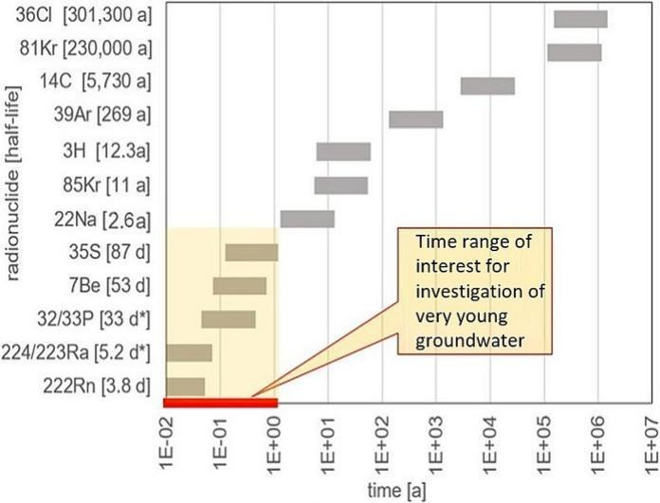
Fig.1 Radionuclide time range of interest for investigation of very young groundwaters.

Method
A ³⁵S input function will need to be established for sound evaluation of the ³⁵S data. Due to the ³⁵S half-life, this should cover a period of twelve months (∼4t½) but at least six months (∼2t½) prior to the groundwater sampling campaign. Pre-concentration of ³⁵S is required since the low natural concentrations of ³⁵S in rain and groundwater necessitate large water sample volumes (20L) to obtain 100 mg SO₄²⁻ as adequate load for sound ³⁵S detection by LSC (Lin et al. 2016). Usually exchange resins in Cl-form are used to pre-concentrate SO₄²⁻ from the original water sample. The resin is subsequently eluted with aqueous NaCl solution and precipitation as BaSO₄ by adding BaCl₂. Schubert et al., (2020) proposes an optimised sample preparation procedure using exchange resin in OH-form, elution with ammonium hydroxide, and evaporation of the eluate. Both methods will be investigated.
Results will be presented at the next New Zealand Hydrological Society Conference.

References

Lin et al., (2016) Simple Method for High Sensitivity Determination of Cosmogenic S35 in Snow and Water from Remote Regions. Anal.Chem 4;89(7):4116-4123. doi: 10.1021/acs.analchem.6b05066.
Schubert, M., Kopitz, J., & Knöller, K. (2020). Low-sulphate water sample preparation for LSC detection of 35S avoiding sulphate precipitation. Journal of Environmental Radioactivity, 213, 106153.
Uriostegui, S.H., Bibby, R.K., Esser, B.K., Clark, J.F. (2015) Analytical Method for Measuring Cosmogenic (35)S in Natural Waters. Anal.Chem 16;87(12):6064-70. doi: 0.1021/acs.analchem.5b00584.

SURFICIAL GROUNDWATER FACIES OF THE COASTAL WAIRAU PLAIN, MARLBOROUGH
Martin Crundwell, Paul White
GNS Science – Te Pū Ao
Aims
The purpose of this study is to establish a spatial framework for surficial groundwater facies and associated hydrological properties across the low-lying Wairau coastal plain, to support 3D-FACIES modelling of the coastal groundwater system beneath the Wairau Plain.
Method
Under the principles of river geomorphology, the characteristics of river channels and associated alluvial facies are strongly linked to river gradients and flows (Bravard and Petit 2009; Buffington and Montgomery 2022). This is evident in the distribution of different types of river channels and alluvial facies across the low-lying coastal Wairau Plain. River gradients and flow velocities were not measured at specific sites across the plain, instead, surficial (relict) river channels are used as proxies for natural (pre-anthropogenic) river gradients and flows and alluvial facies. Relict river channels and alluvial facies are mapped and classified using filtered digital terrain models (fDTM) derived from high-resolution MDC airborne LiDAR (Light Detecting and Ranging) data (Figure 1).
Results
Aquifer facies of the low-lying coastal Wairau Plain are largely comprised of coarse-grained fluvial fan and braidplain facies. Surficial fluvial fan facies are associated with catchments along the southern and northern flanks of the plain where gradients are relatively-high (~1:100 to 1:400), and surficial braidplain facies dominate the western part of the coastal plain where gradients are moderate (~1:400 to 1:700). Transitional overbank and braidplain facies interfinger in the central part of the plain where gradients are relatively-low (~1:700 to 1:1000). This critical depositional threshold where coarse-grained braidplain gravels interfinger with fine-grained overbank deposits are associated with groundwater outflow and spring-fed streams. It also marks the natural (pre-anthropogenic) transition from coarse-grained riverbed sediment cover to fine-grained sediment cover. Fine-grained aquiclude facies are mainly associated with meandering rivers and coastal floodplain facies where gradients are very low (~1:1000 to 1:3000). Surficial floodplain facies are developed in a broad belt that spans most of the flat low-lying coastal plain, and they are associated with less widespread aeolian dune and swamp facies. These fine-grained coastal facies are bordered by marginal marine facies, including estuary and lagoon, beach, and shallow marine. Sedimentary deposits associated with these different groundwater facies (Table 1), and spatial facies relationships, are shown in Figure 1. The arrangement of groundwater facies in the coastal Wairau Plain is typical of most low-lying coastal plains with large catchments that drain high mountains.
Table 1: Groundwater facies of the coastal Wairau Plain.
Setting | Depositional environment (facies) | Sedimentary deposits
Coastal plain  gradients  ~1:100 to 1:1000 | Fluvial fan | Subangular gravel, sand, silt
Coastal plain  gradients  ~1:100 to 1:1000 | Braided river (braidplain) | Subrounded/rounded gravel, sand, silt
Coastal plain  gradients  ~1:100 to 1:1000 | Transitional (overbank + braidplain) | Silt, sand, gravel
Coastal floodplain  gradients  ~1:1000 to 1:3000 | Overbank (coastal floodplain) | Silt, sand, gravel
Coastal floodplain  gradients  ~1:1000 to 1:3000 | Dune | Sand
Coastal floodplain  gradients  ~1:1000 to 1:3000 | Swamp | Peat (organic matter), wood, mud
Marginal marine | Estuary and Lagoon | Mud, sand, gravel, shell
Marginal marine | Beach and Beach ridge | Sand, gravel, cobble, shell
Marginal marine | Shallow (continental) shelf | Mud, sand, gravel, shell
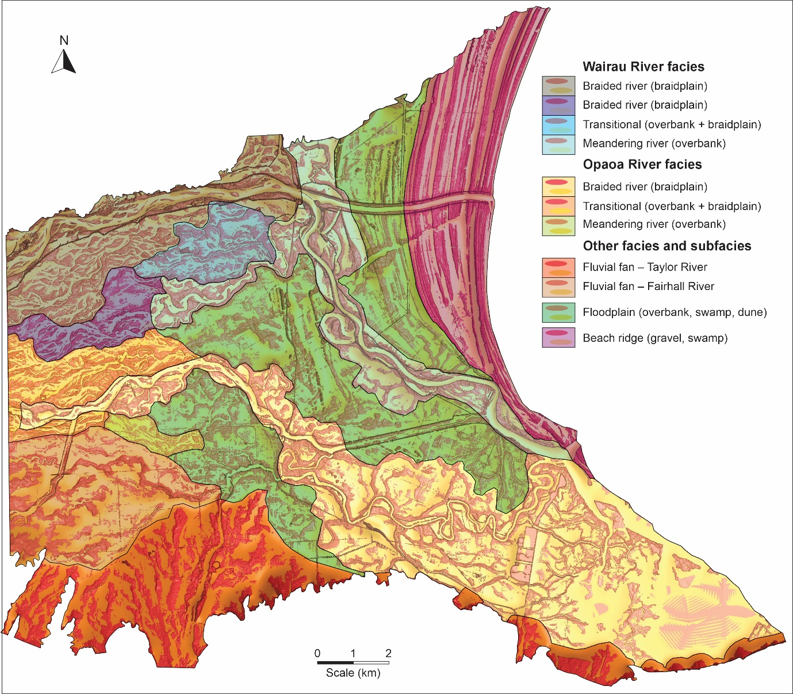
Figure 1: Low-lying Wairau coastal plain fDTMs, showing the distribution of different surficial groundwater facies, based on relict river channel morphologies.
Constancy in the distribution and relationships of groundwater facies is important in groundwater modelling because it provides some predictability to the distribution of aquifers and aquicludes and how hydrological properties change between boreholes. Using ‘facies’ and the principles of ‘sequence stratigraphy’ where the predictable pattern of alluvial sedimentary facies equilibrates to sea-level, also provides insight to the depositional architecture and formation of the groundwater systems beneath coastal plains, and how groundwater systems will respond to future environmental changes related to vertical land movements (tectonics), sediment supply, and sea-level. For example, if sea-level rises, surficial alluvial facies will shift inland and the spatial relationships between adjacent facies will be maintained; sea-level falls will result in a wholesale seaward shift of facies. The rate and distance that alluvial facies shift in response to changes in ‘absolute’ sea-level is unknown, but a number of factors are important: 1) the rate and magnitude of sea-level change, 2) the gradient of the land surface, 3) river management infrastructure, and 4) the time rivers and alluvial facies take to reequilibrate to the change in sea-level.
References
Bravard JP, Petit F. 2009. Geomorphology of streams and rivers. In: Likens GE, editor.
Encyclopedia of inland waters. Oxford (GB): Academic Press. p. 387–395.
Buffington JM, Montgomery DR. 2022. Geomorphic classification of rivers: an updated review.
In: Shroder JF, editor. Treatise on geomorphology. 2nd ed. Oxford (GB): Academic Press. p. 1143–1190.

Effect of RIver Management on regional Groundwater levels

Wilson S¹, Measures R², Hoyle J², Durney, P¹, Wöhling T^{1,3}
¹ Lincoln Agritech
² National Institute of Water & Atmospheric Research
³ Chair of Hydrology, Technische Universität Dresden, Dresden, Germany

Aims
The aim of this work is to determine if long-term trends of declining groundwater levels can be explained by the engineering of braided rivers for flood management. A braided river can be considered as a “river system” consisting of surface channels and an intrinsically linked subsurface gravel reservoir, the “braidplain aquifer” (Wilson et al., 2024). This conceptualisation implies that for settings where the river system is hydraulically disconnected to the regional aquifer, groundwater recharge is largely governed by braidplain aquifer width. Additionally, for settings where the river system is hydraulically connected to the regional aquifer, river bed levels will have a large control on recharge rates since they determine the hydraulic gradient. Consequently, the effect of river management on groundwater recharge will depend on the hydraulic setting of the river system.
Method
To test the impact of river management on groundwater recharge, long-term records of river mean bed level from surveyed cross sections were compared to groundwater levels for the Wairau and Ngaruroro rivers in New Zealand. Scenario testing for different river system widths and elevations was also conducted in MODFLOW based on shorter term monitoring records. An existing model for the Wairau was used (Wöhling et al. 2017), and a new model was developed for the Ngaruroro system (Durney & Wilson 2024).

Results
In New Zealand, groundwater monitoring commenced after the river flood engineering schemes of the 1960’s, so the impact of river narrowing is not captured by groundwater records. However, hydraulically connected recharge reaches of the Wairau and Ngaruroro river systems have both been subject to more recent bed degradation caused by gravel extraction. The long-term groundwater level decline in the regional aquifers clearly mimics the drop in mean bed levels in the recharge reaches of the rivers. The drop in river bed elevations can also account for the decline in groundwater levels in MODFLOW scenario modelling.
Observation data for the Wairau and Ngaruroro systems show that the dynamic component of recharge pulses from flood flows propagate rapidly through their associated highly transmissive alluvial aquifers. For both hydraulically connected and disconnected braidplain aquifer-regional aquifer settings, maintaining a steady rate of recharge is therefore most beneficial for sustaining groundwater levels throughout the year. The observation data and modelling results confirm that gravel extraction in the braidplain aquifer is having the largest impact on the hydrological function of the regional aquifer in the two hydraulically connected systems studied here. In both cases, the decline in bed levels offsets the benefit of recharge sourced from flood flow events.

References
Durney, P., Wilson, S. 2024. Ngaruroro Groundwater Model and River Management Scenarios. Technical Report for Hawkes Bay Regional Council, Lincoln Agritech, 47pp.
Wilson, S. R., Hoyle, J., Measures, R., di Ciacca, A., Morgan, L. K., Banks, E. W., Robb, L., & Wöhling, T. (2024). Conceptualising surface water–groundwater exchange in braided river systems. Hydrology and Earth System Sciences, 28(12), 2721–2743. https://doi.org/10.5194/hess-28-2721-2024
Wöhling, T., Gosses, M. J., Wilson, S. R., & Davidson, P. (2017). Quantifying River-Groundwater Interactions of New Zealand’s Gravel-Bed Rivers: The Wairau Plain. Groundwater. https://doi.org/10.1111/gwat.12625

